NAME: CHRISTINA JOSE MANAKKAL

ROLL NO: 48 CLASS: TE IT B3 PID: 191064

St. Francis Institute of Technology, Mumbai-400 103

**Department Of Information Technology**

A.Y. 2021-2022

Class: TE-IT B, Semester: V

Subject: **DevOps Lab**

**Experiment – 5:** **To build pipeline of jobs in Jenkins, create a pipeline script to test and deploy an application.**

1. **Aim:** To build pipeline of jobs in Jenkins, create a pipeline script to test and deploy an application
2. **Objectives:** Aim of this experiment is that, the students will be able

* To build pipeline of jobs in Jenkins, create a pipeline script to test and deploy an application

1. **Outcomes:** After study of this experiment, the students will be able

* To understand the importance of Jenkins to Build and deploy Software

Applications on server environment.

1. **Prerequisite:** Knowledge of software engineering concept of integration and deployment
2. **Requirements:** Jenkins,JDK, python,Personal Computer, Windows operating system, browser, Internet Connection, Microsoft Word.
3. **Pre-Experiment Exercise:**

**Brief Theory:** Refer shared material

1. **Laboratory Exercise**
   * + 1. **Procedure:**

**a. Answer the following:**

* What is Jenkins pipeline?

Jenkins Pipeline (or simply "Pipeline") is a suite of plugins which supports implementing and integrating continuous delivery pipelines into Jenkins.A continuous delivery pipeline is an automated expression of your process for getting software from version control right through to your users and customers.

Jenkins Pipeline provides an extensible set of tools for modeling simple-to-complex delivery pipelines "as code". The definition of a Jenkins Pipeline is typically written into a text file (called a Jenkinsfile) which in turn is checked into a project’s source control repository.

* What are the different ways to write a Jenkins pipeline?

Ways to write pipeline:

1. Scripted (implicit)

2. Declarative (explicit, special file- Jenkinsfile)

**b**. **Execute following (Refer the shared material) and attach screenshots:**

* Create and build pipeline project with Git
* Create and build pipeline project with pipeline script

1. **Post-Experiments Exercise**
2. **Extended Theory:**

Nil

1. **Questions:**

* Explain the types of agents in a Jenkinsfile?
* What are webhooks?

1. **Conclusion:**

* Write what was performed in the experiment.
* Write the significance of the topic studied in the experiment.

1. **References:**

<https://jenkins.io/doc/>

<https://www.edureka.co/blog/jenkins-pipeline-tutorial-continuous-delivery>

<https://www.slideshare.net/abediaz/introduction-to-jenkins>

<https://www.slideshare.net/jph98/jenkins-ci-presentation>

**7b. Execute following (Refer the shared material) and attach screenshots:**

1. Create and build pipeline project with pipeline script

• Project with Hello World pipeline script

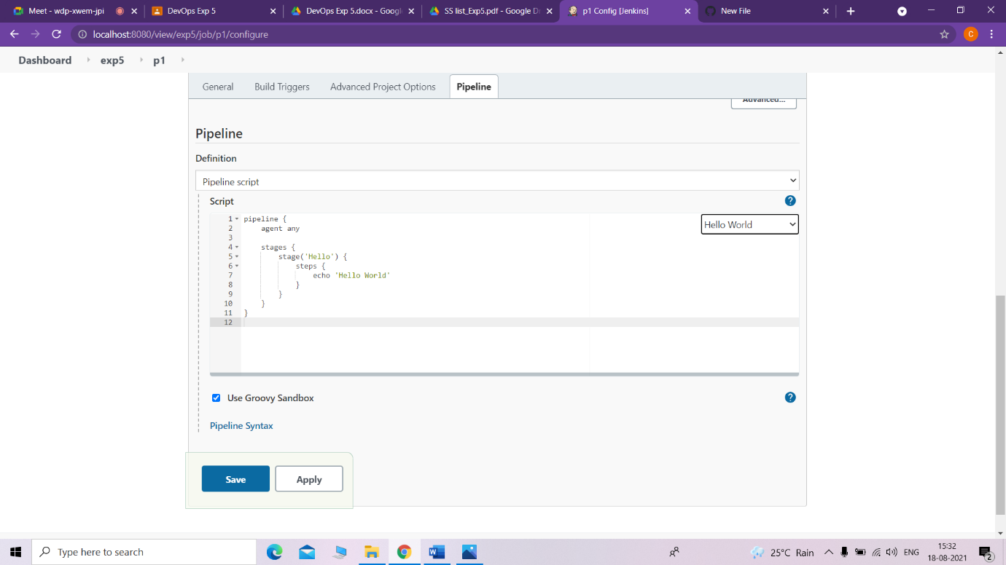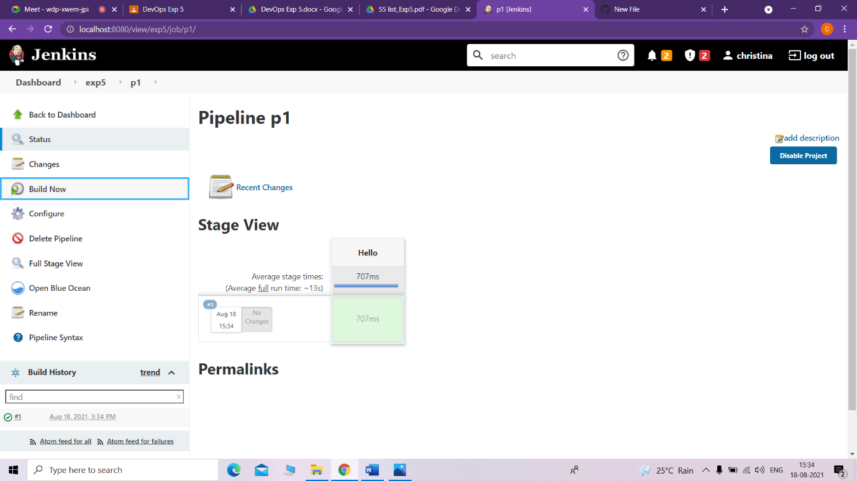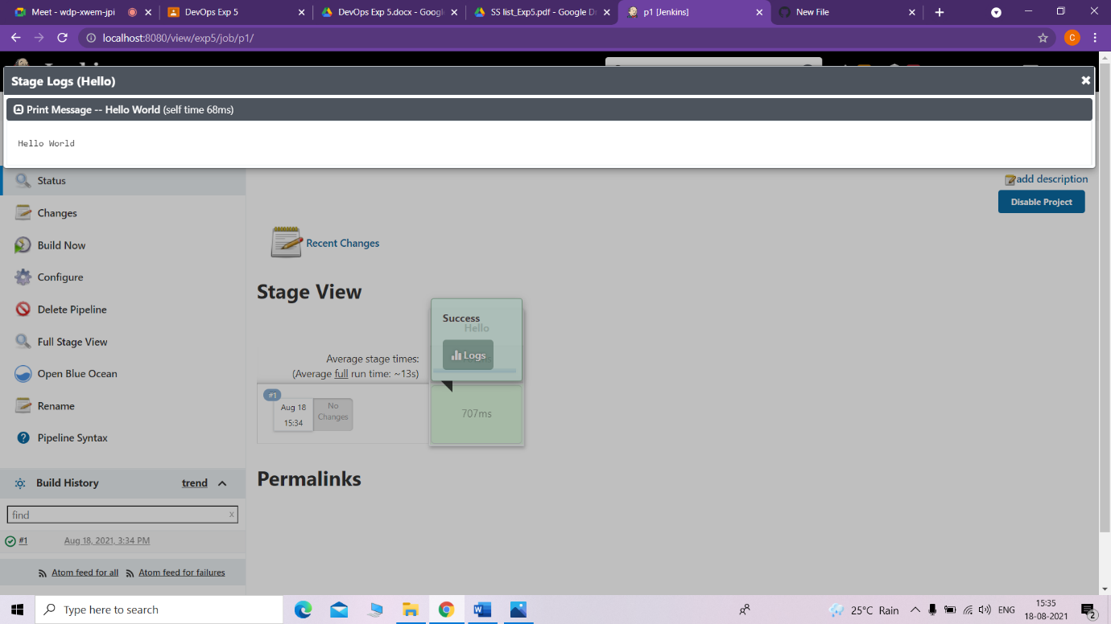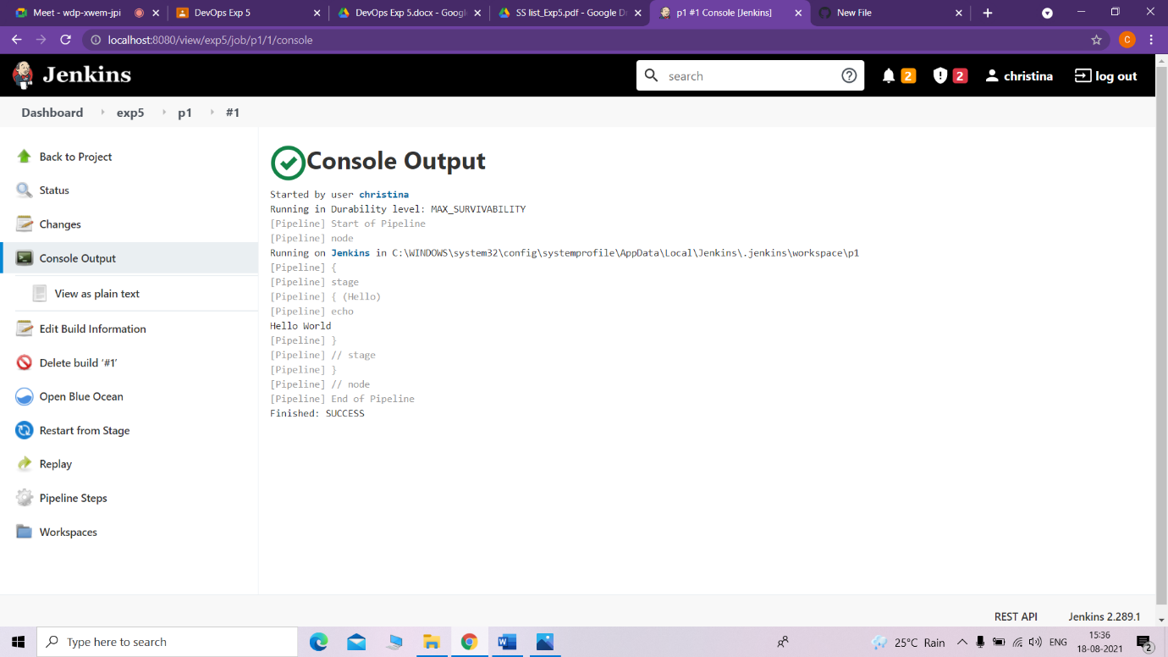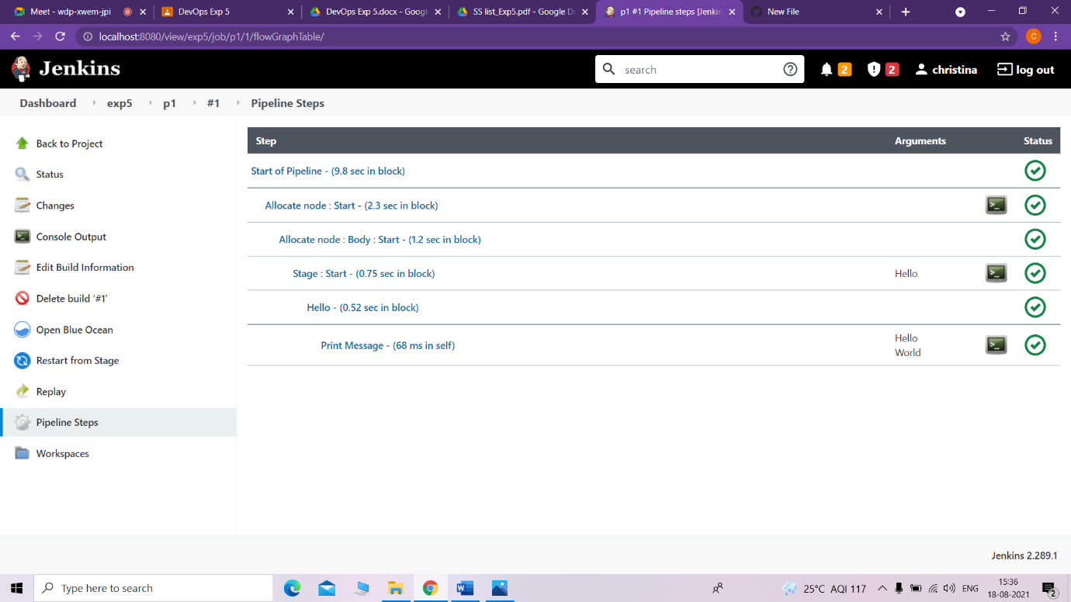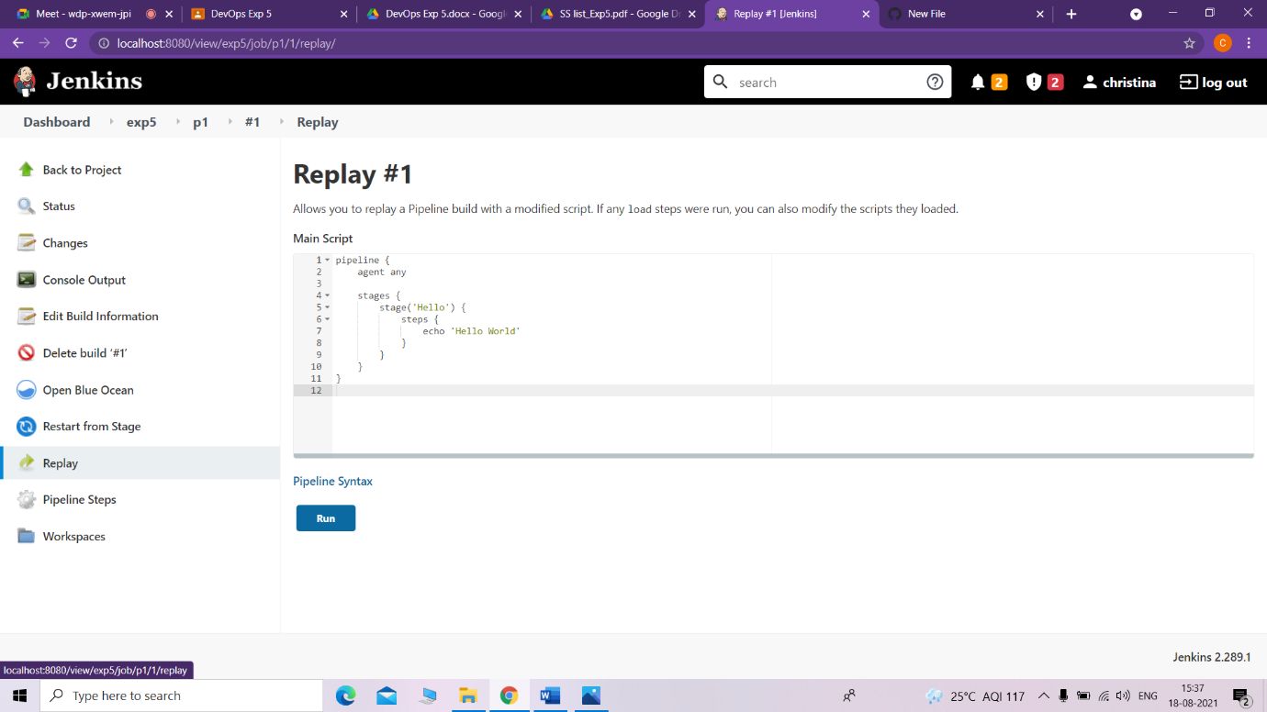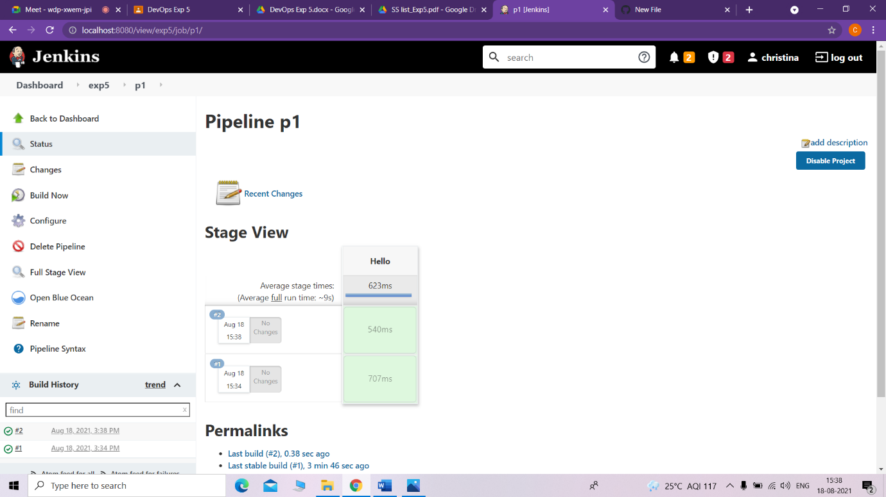

• Project with your own pipeline script

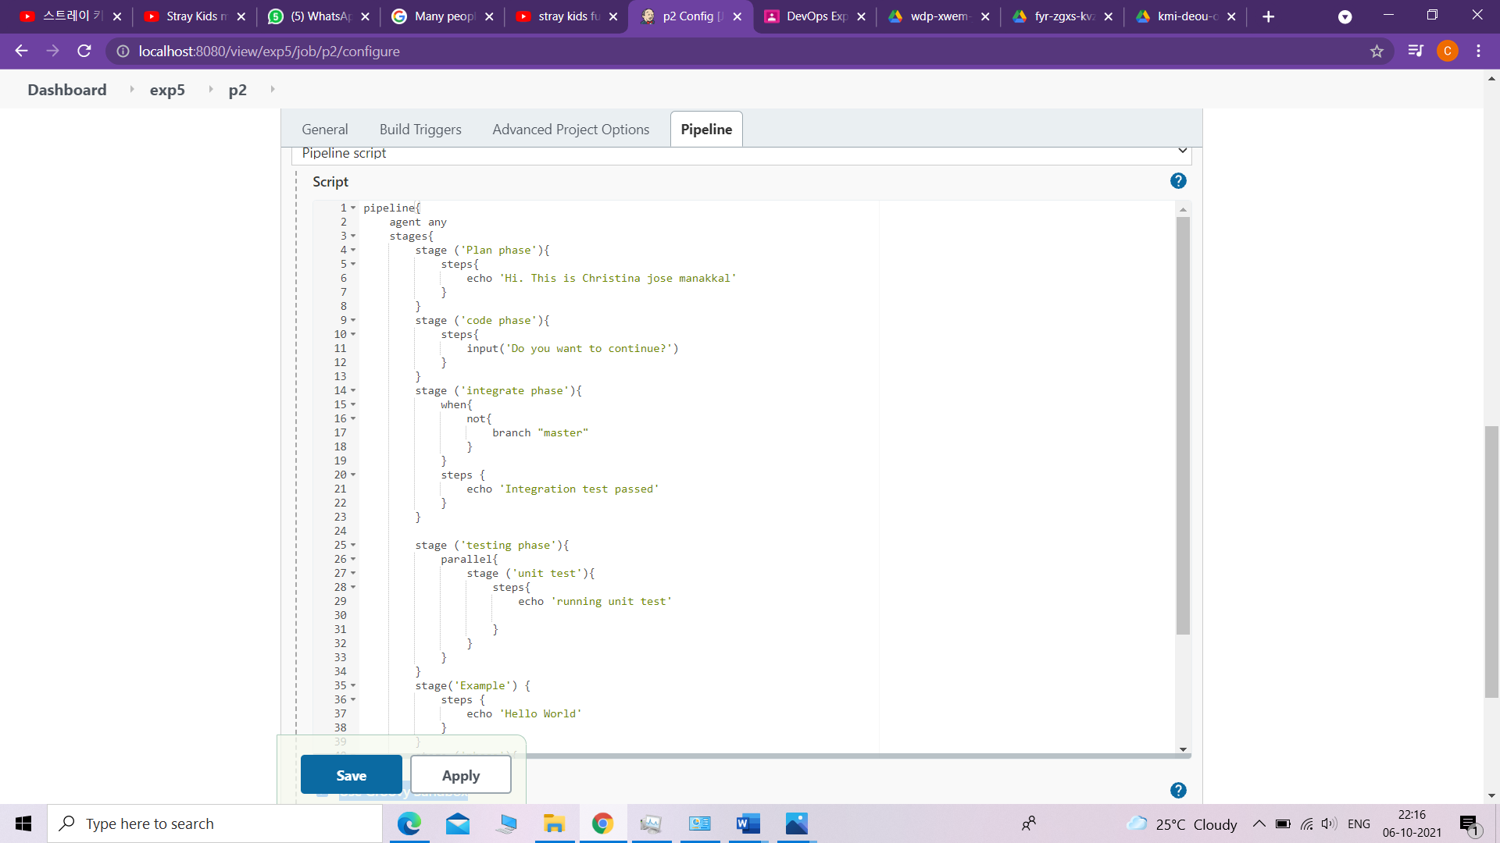

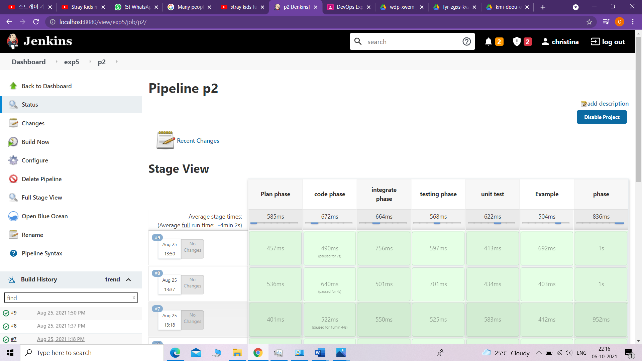

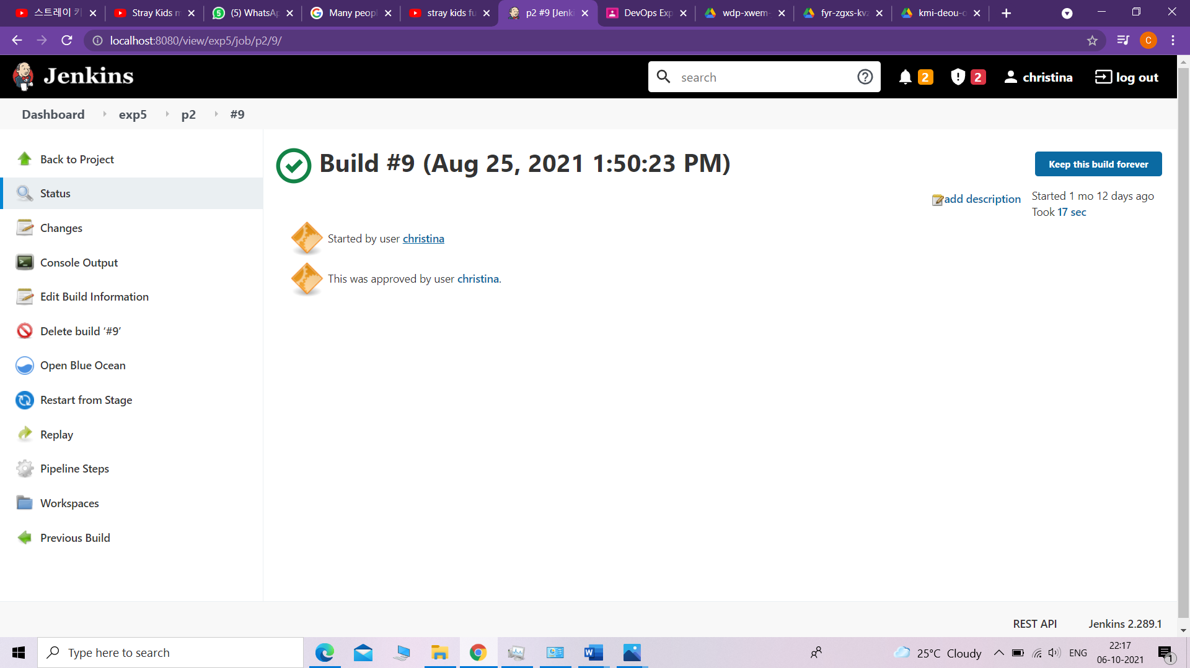

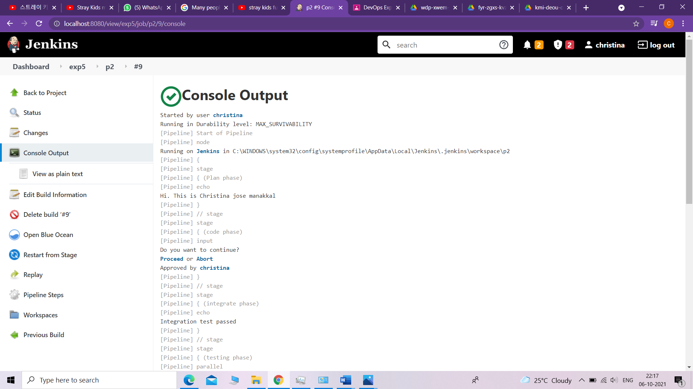

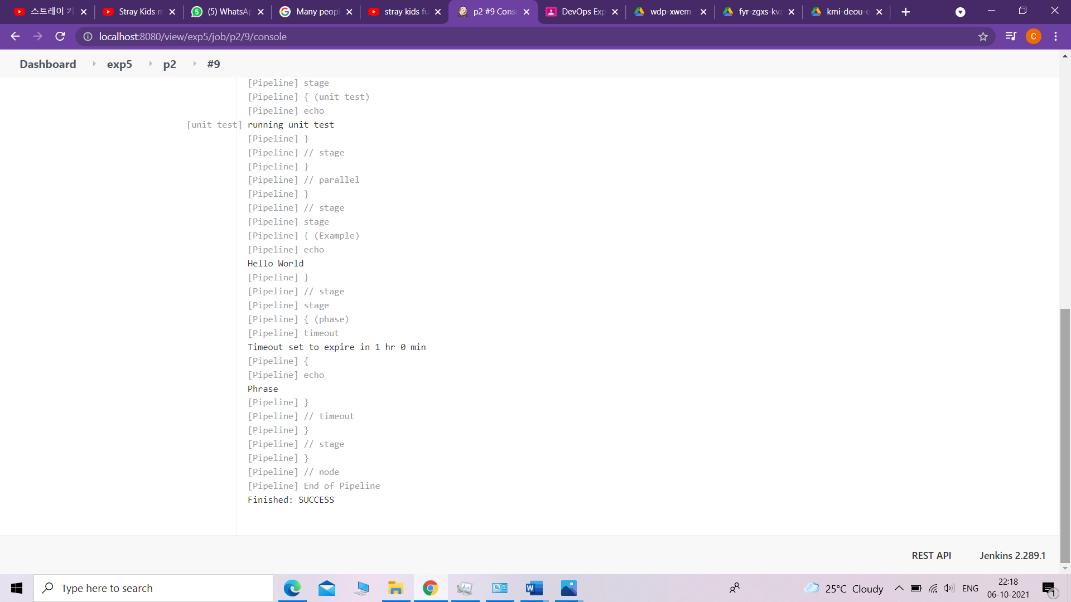

2. Create and build pipeline project with Git

• Fork repository on GitHub

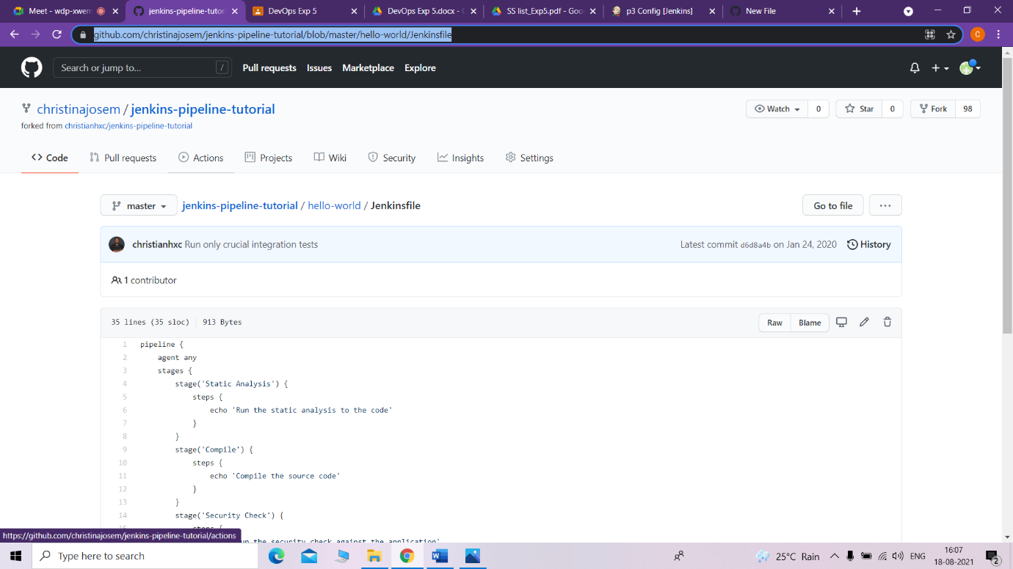

• Create pipeline project with pipeline script from SCM

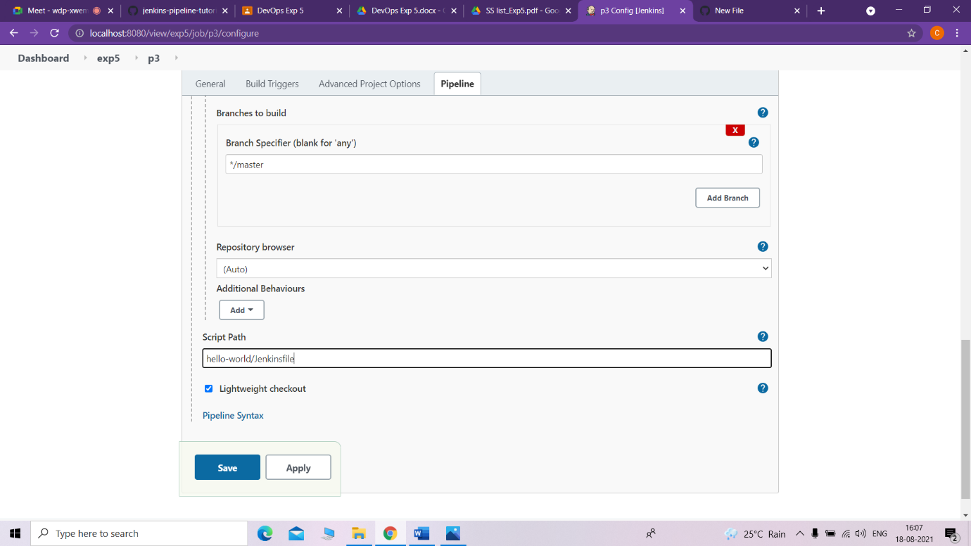

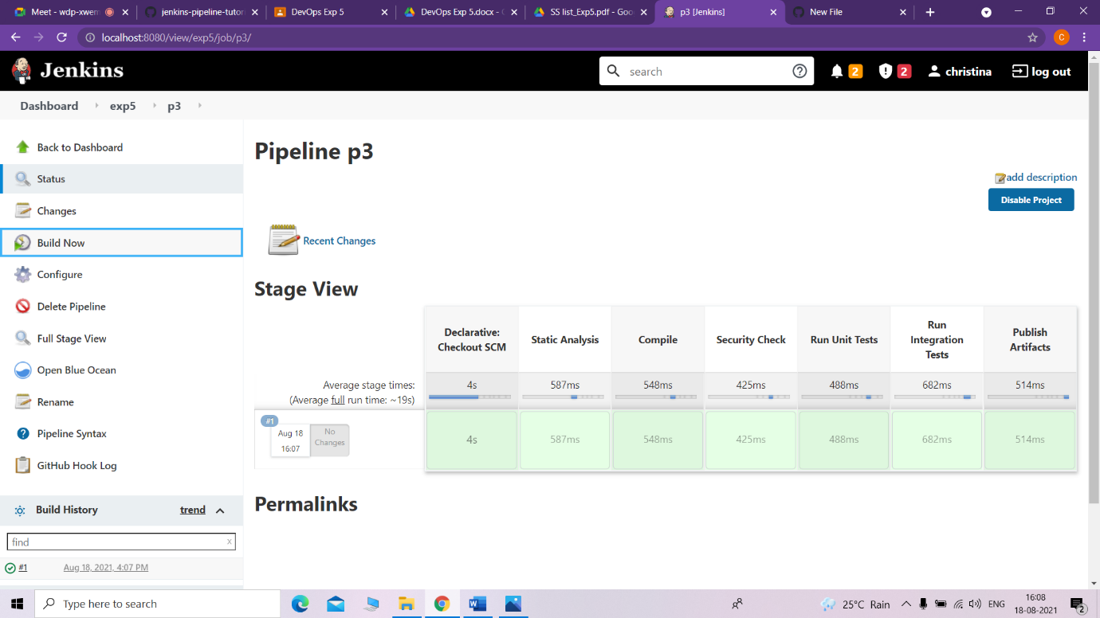

• Add webhooks to the forked repository

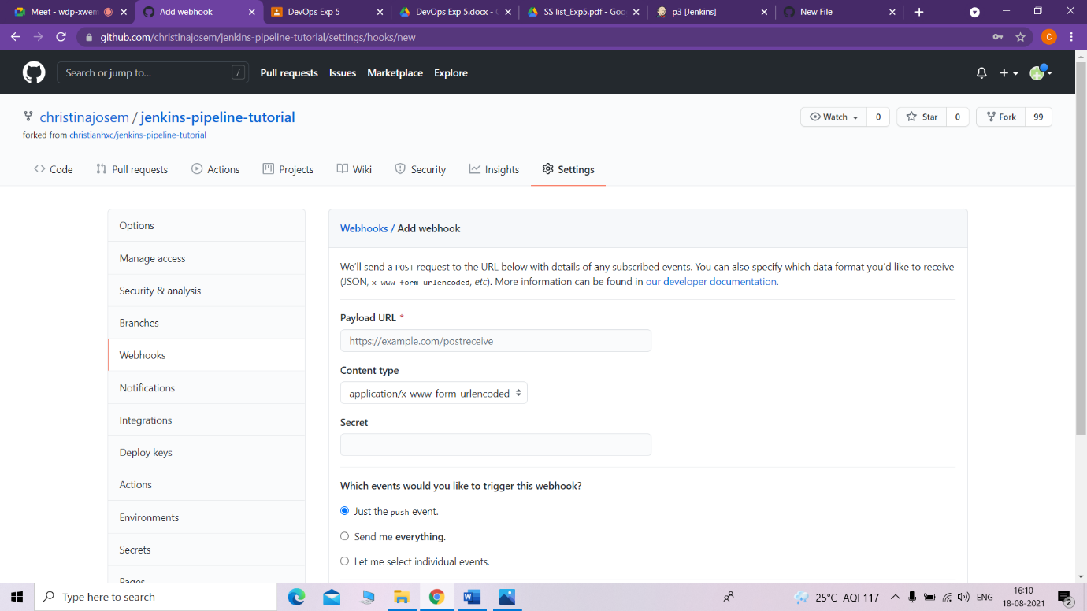

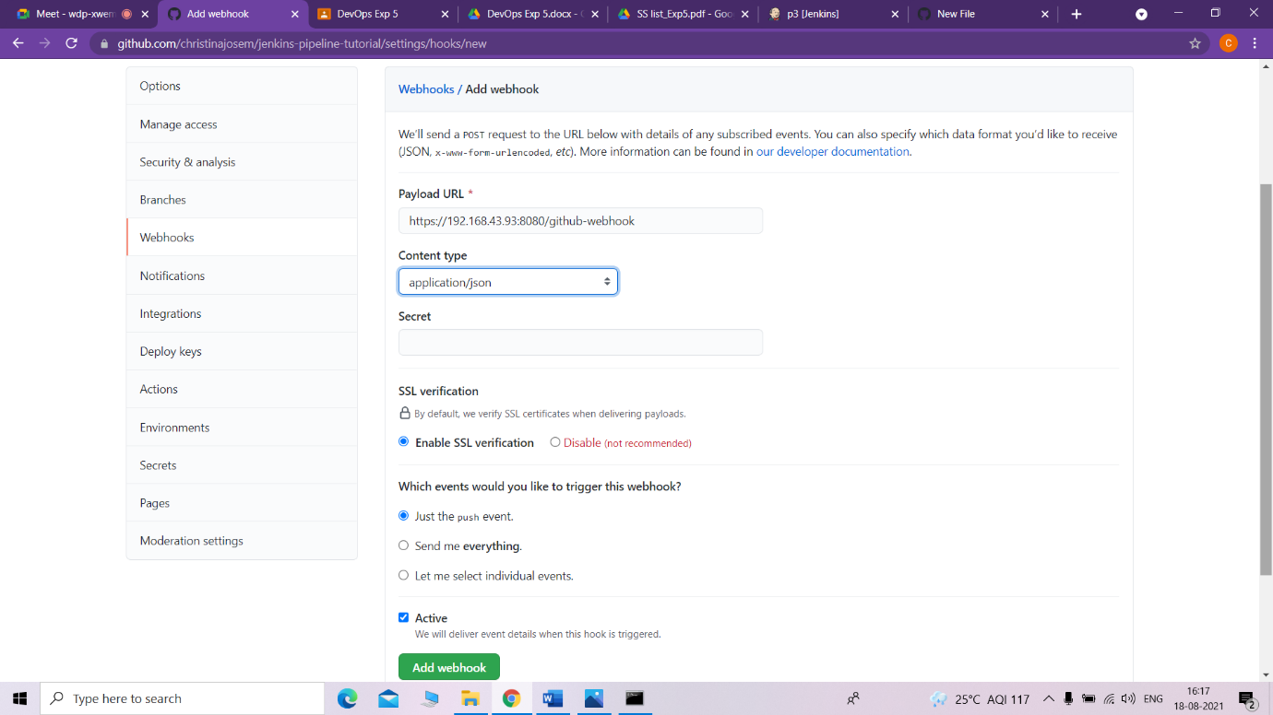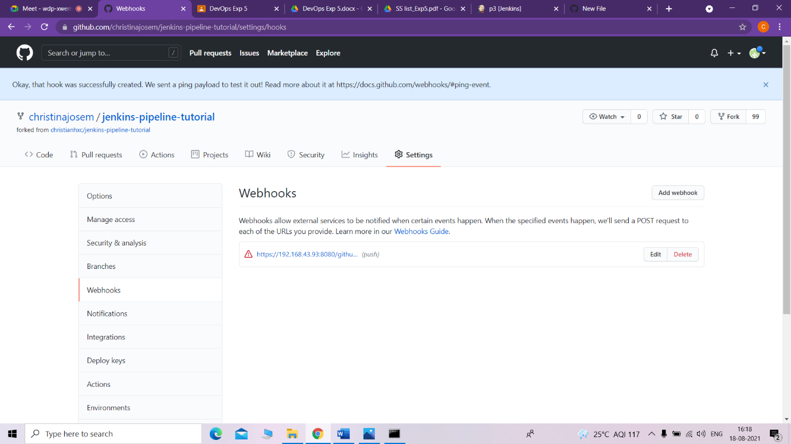

• Build pipeline project

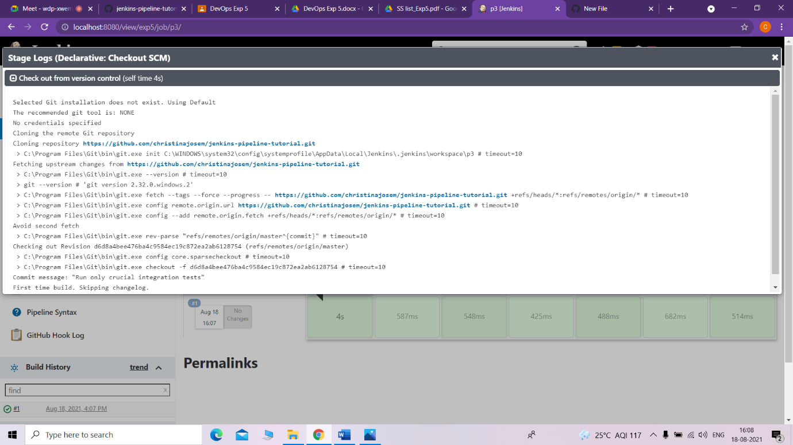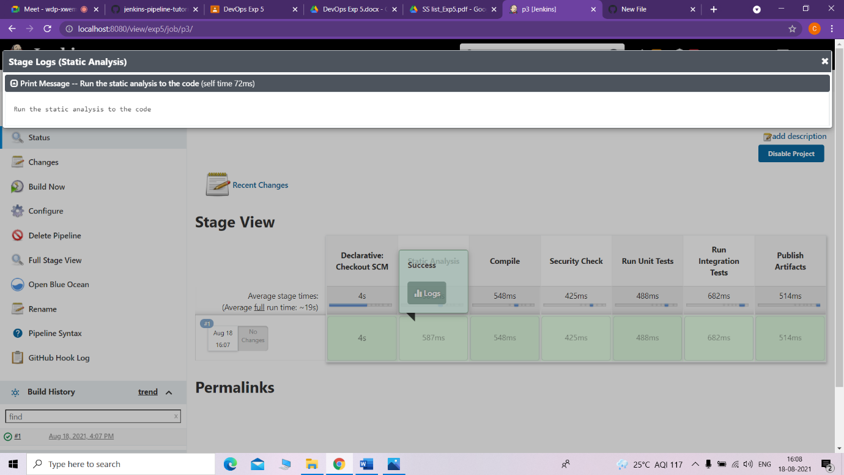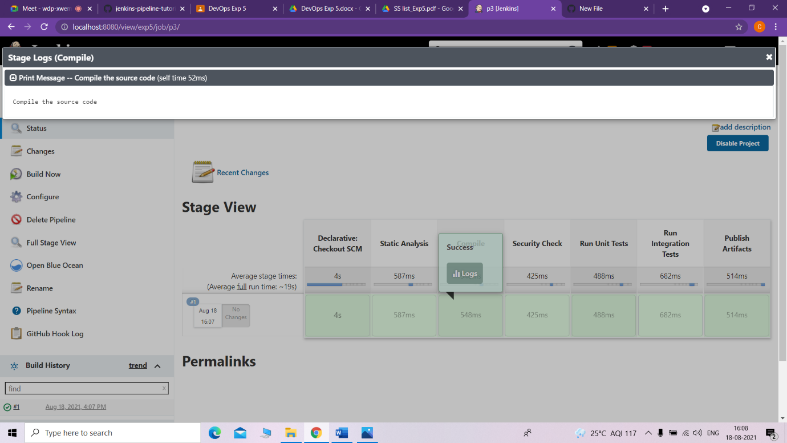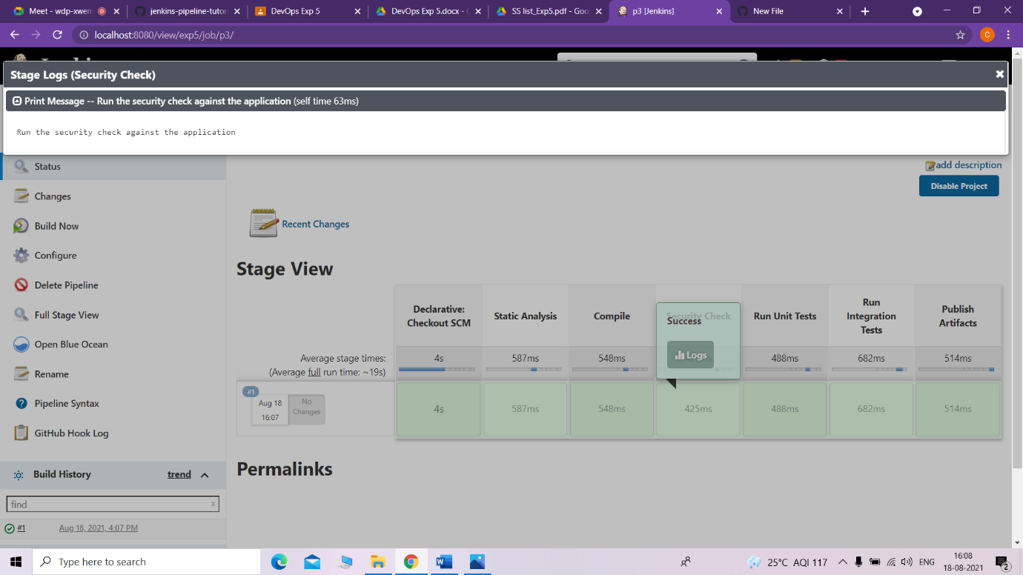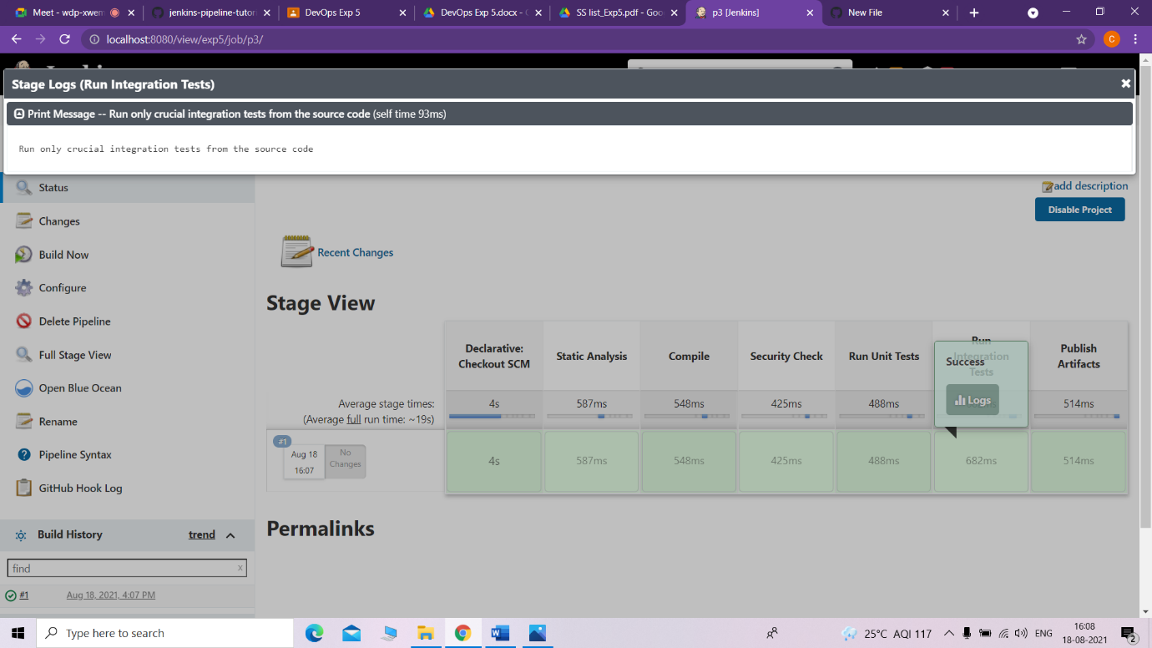

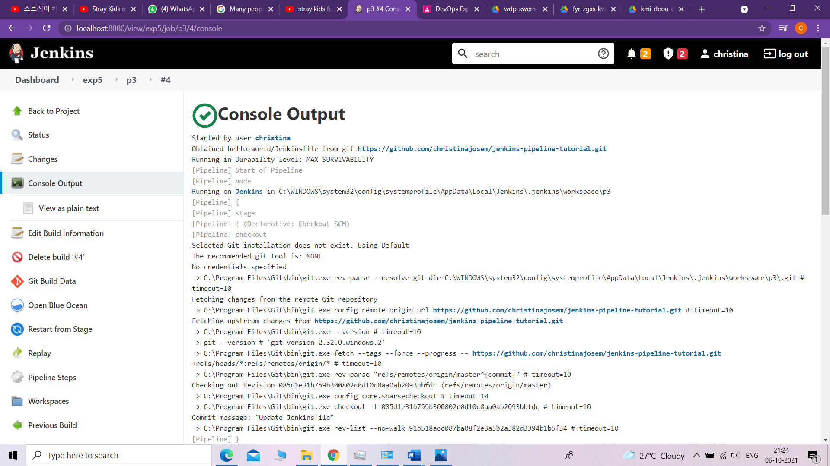

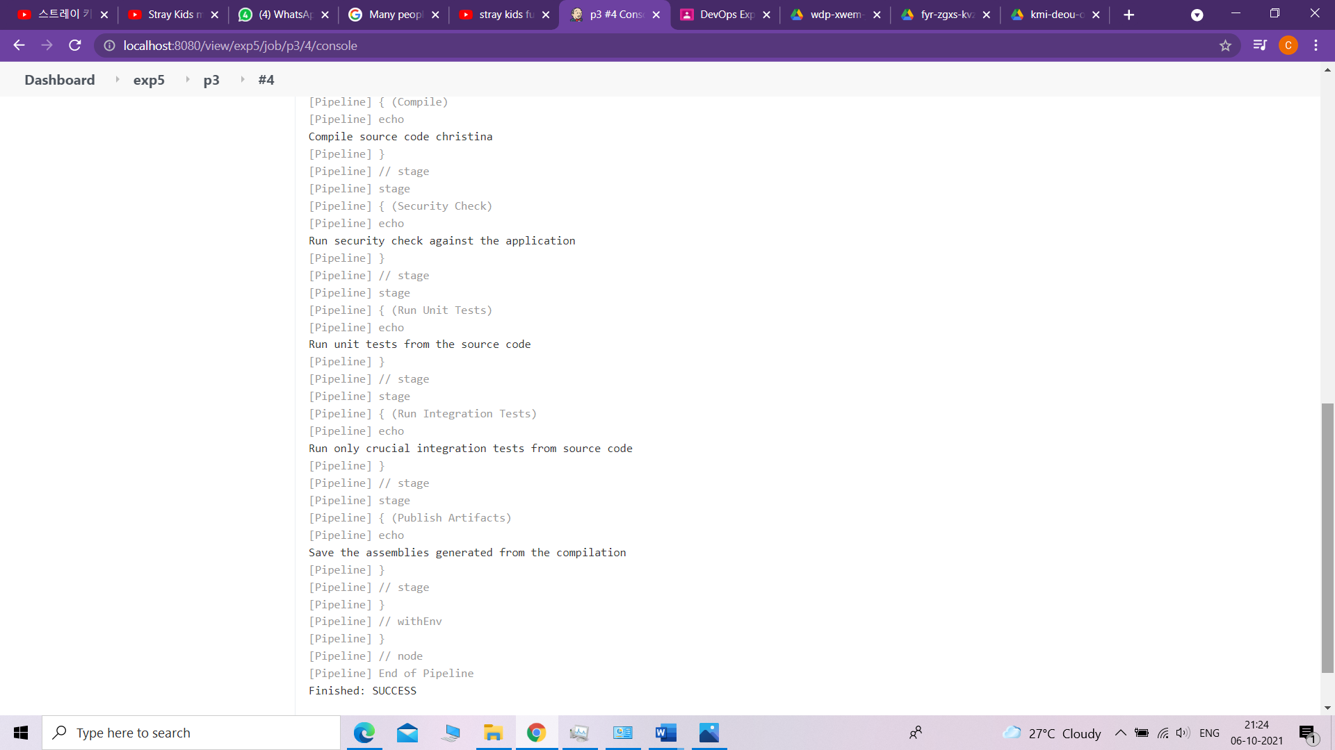

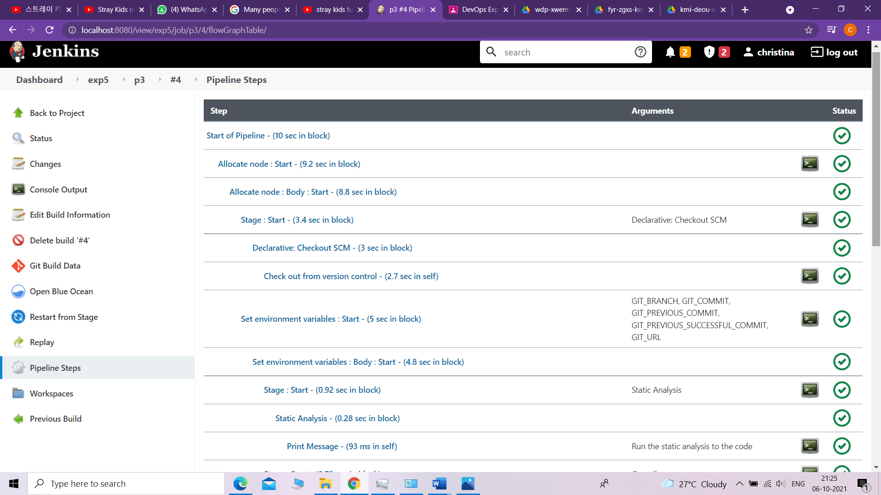

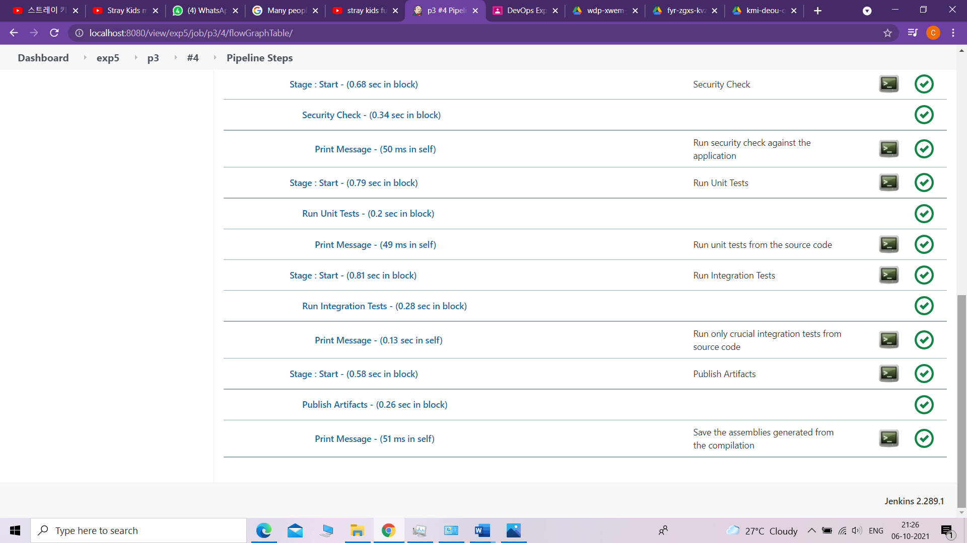

• Add file to forked repository and build

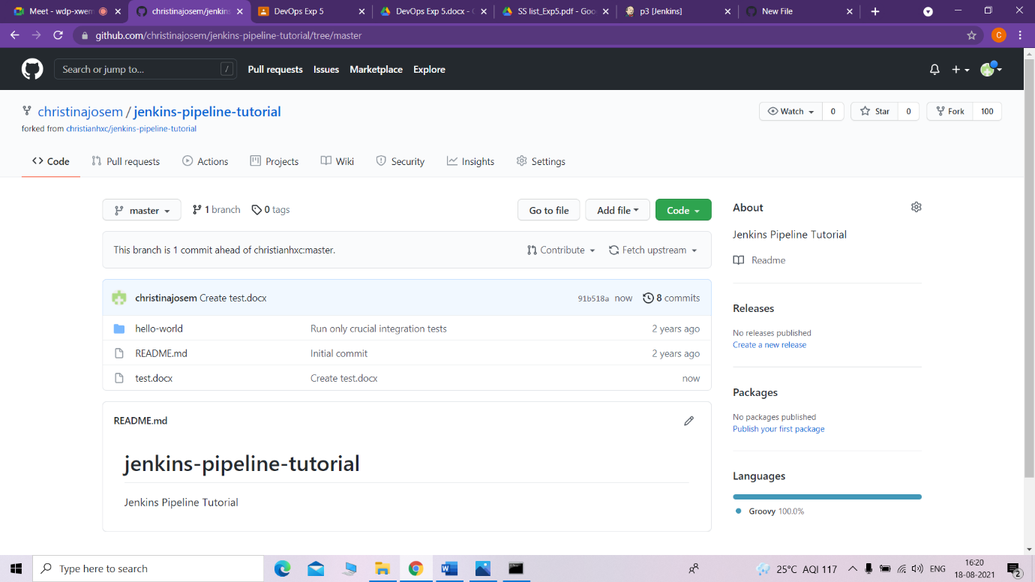

s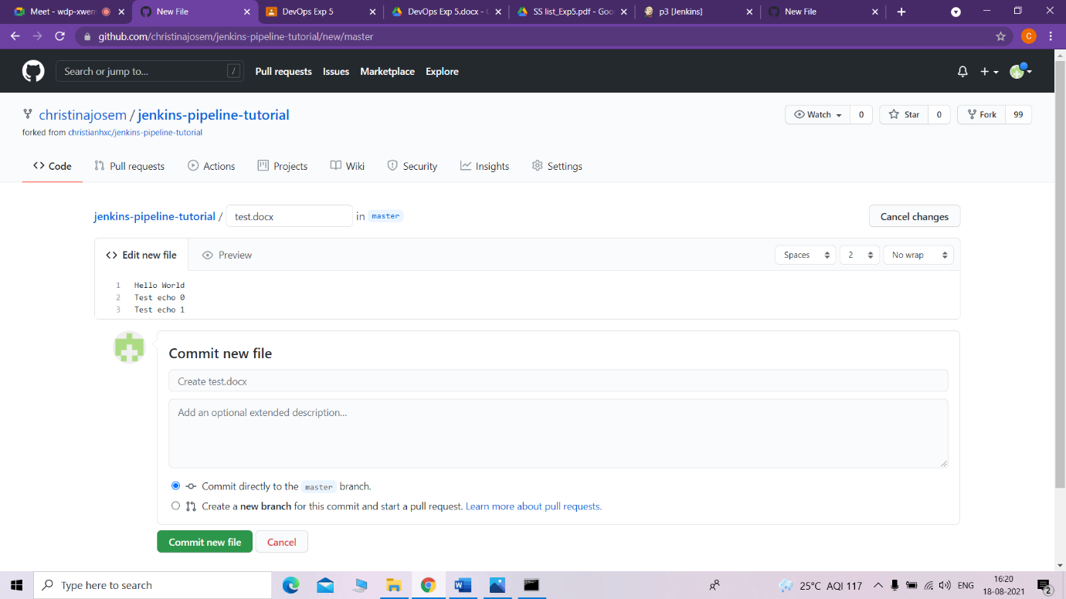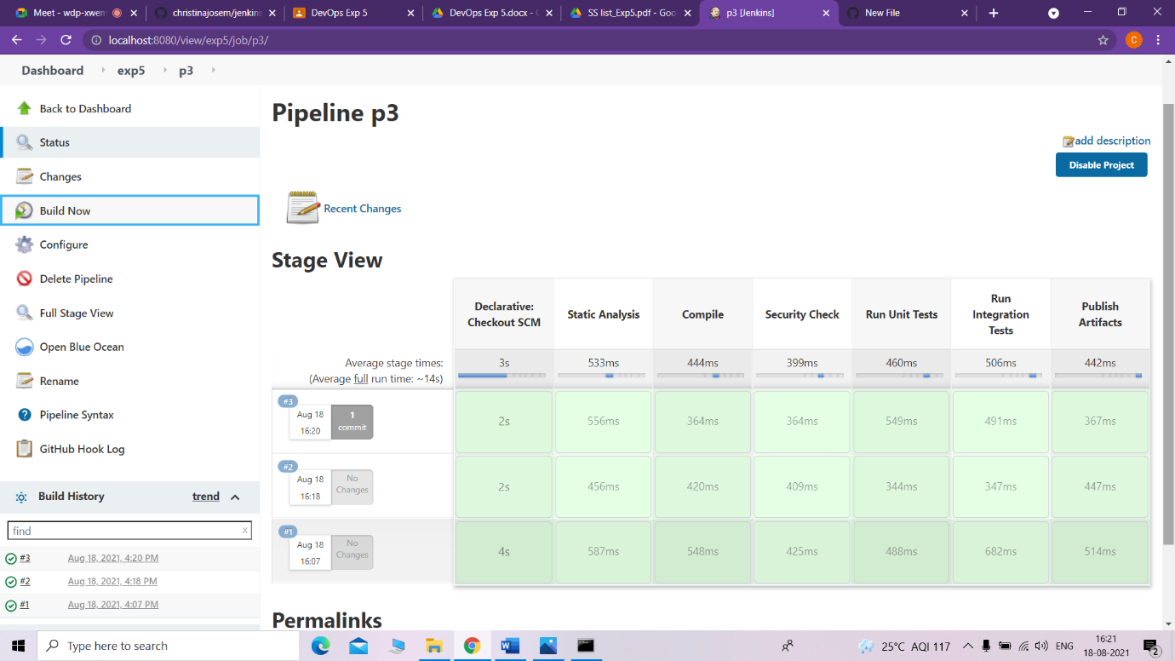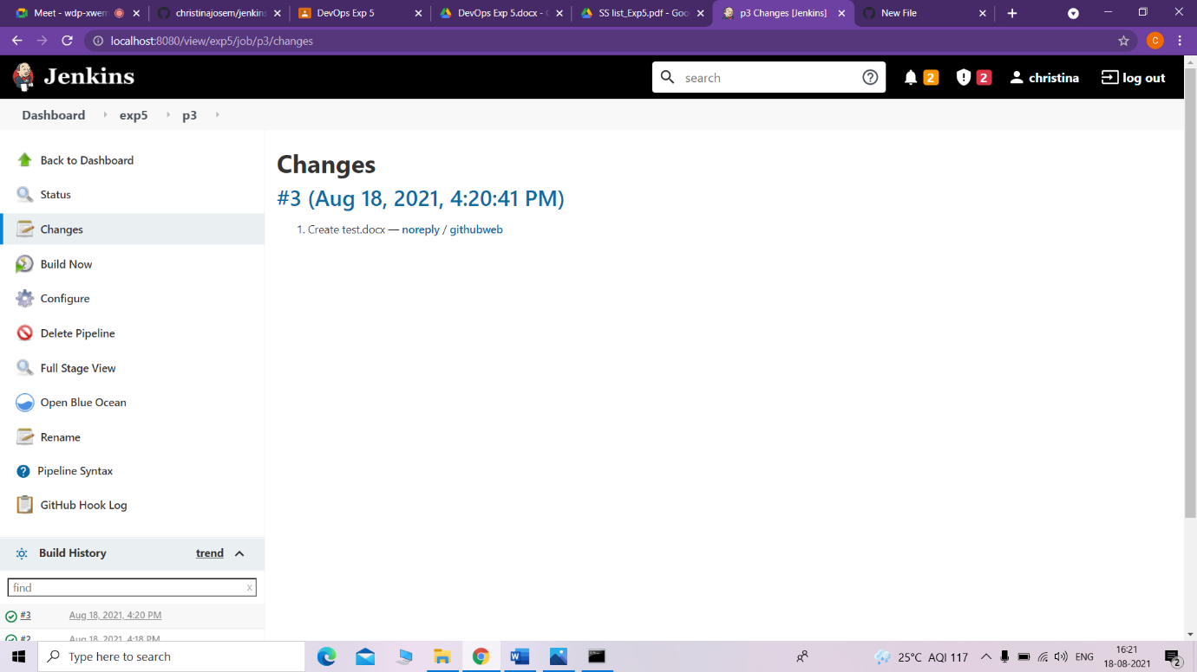

• Make changes to Jenkins file on forked repository and build

